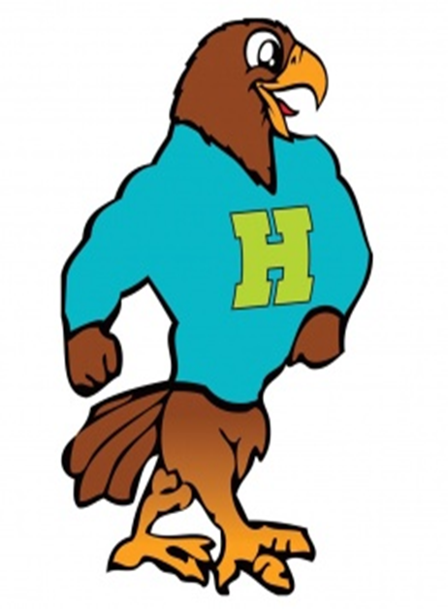

**Herbert Akins Road Elementary**

**Fourth Grade Supply List 2024 - 2025**

|  |  |  |
| --- | --- | --- |
| Item | Amount Needed | Notes |
| * 5 subject notebook | 1 |  |
| * Plastic folders *(with prongs)* | 2 | * **Ms. Clayton Track 4 and Ms. Winsor Track 1** , 4 folders ( Red, Blue, Green, Yellow) |
| * Packs of notebook paper (wide ruled) | 2 |  |
| * Pencil Cap Erasers | 1 |  |
| * Zippered pencil pouch | 1 |  |
| * Box of 36 pencils or 3 boxes of 12 pencils |  | (Ticonderoga preferred)- NO MECHANICAL PENCILS |
| Expo Markers | 4 |  |
| Glue sticks | 2 |  |
| Pair of earbuds / headphones | 1 | (for personal use only) - must be left at school |
| Package of sticky notes | 1 |  |
| Box of Kleenex | 2 |  |
| 1 roll of paper towels **AND** 1 package of baby wipes | 1 | Boys Bring |
| 1 canister of Clorox / Lysol Wipes | 1 | Girls Bring |
| 1 Pack Colored Pencils | 1 |  |
| 1 Pair Scissors | 1 |  |

**\*\*Individual teachers may request additional supplies to support learning in their classroom. Please check in with your teacher at our Meet the Teacher event in July. Feel free to bring supplies to the Meet the Teacher event.**